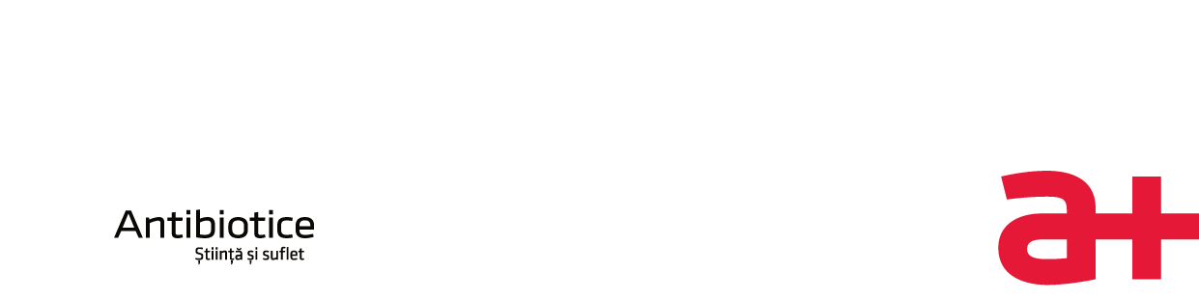

**Informational material for item 1 on the agenda of the Extraordinary General Meeting of Shareholders of Antibiotice S.A. from 30/31.10.2023**

1. Antibiotice S.A., the most important manufacturer of medicines with Romanian capital, has strategically planned its activity for the period 2020-2030. The Business Plan "The Future Together 2020-2030" - the management component of the Management Plan approved by the shareholders - establishes the financial and non-financial indicators staged for the time intervals 2020-2024, 2025-2028 and 2029-2030.

Important investments are planned to support the Business Plan, with an estimated value of 360 million lei until 2025 and further 450 million lei in the period 2026-2030.

1. One of the most important investments included in the Business Plan "The Future Together 2020 -2030" is the achievement of the "Facility for production, packaging and storage of sterile products, solutions and topical products" with an estimated value of 200 million lei, of which 170 millions of lei are eligible expenses according to G.D. no. 807/2014. Antibiotice S.A. obtained from the Ministry of Finance the financing agreement for 50% of the amount of eligible expenses and the remaining amount will be covered from our own sources.
2. The Ministry of Finance accepted the investment project regarding the creation of a "Facility for production, packaging and storage of sterile products, solutions and topical products" and it issued the Financing Agreement no. 538/ 17.06.2023 informing us that "*following your request registered at the General Registry of the Ministry of Finance with no. 1025028/26.07.2022, we inform you of the agreement for the financing of the following eligible expenses worth 85,002,772 lei related to the investment project Facility for production, packaging and storage of sterile products, solutions and topicals. (…) Special notes: Within 6 months from the date of issuance of the Financing Agreement, Antibiotice will present a certain source of financing whose total value is at least equal to the difference between the value of the investment project and the value of the approved state aid. The supporting documents necessary to demonstrate the existence of the trustworthy financing source are provided for in letter a), chapter 2.3.5 Annex 3 of the Applicant's Guide. (G.M.S. decision of the beneficiary of state aid regarding the provision of financing sources, approving the conclusion of a credit agreement in favor of the enterprise, with the specific purpose of financing the investment project • Loan contract)*”.
3. To ensure a trustworthy source of financing, in accordance with the own procedures for purchasing services, based on the decision no. 1 of 14.09.2023 of the Management Board, Antibiotice S.A. sent requests for offers to three banking institutions, requesting the contracting of a loan of 25 million euros for a period of at least 8 years with a grace period of 2 years, for which the bank will not request guarantees from Antibiotice. The purpose of the loan is to finance the Business Plan and to co-finance the investment that is the subject of the Financing Agreement of the Ministry of Finance. After receiving the offers and after the analysis thereof within the Management Board, it will choose the bank with which the credit agreement will be concluded.
4. The proposal of the Management Board will be subject to the approval of the Extraordinary General Meeting of Shareholders in the meeting of October 30, 2023.

This informative material will be supplemented with additional information following the development of the stages specified above.

General Director,

ec. Ioan NANI